34.89: a) For the first lens: 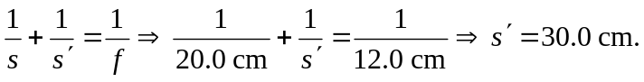
So 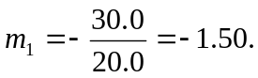
For the second lens:
So the image is 28.0 cm to the left of the second lens, and is therefore 19.0 cm to the left of the first lens.
b) The final image is virtual.
c) Since the magnification is the final image is erect and has a height

